**Exercise: 10**

**1)**

**iPadPro**

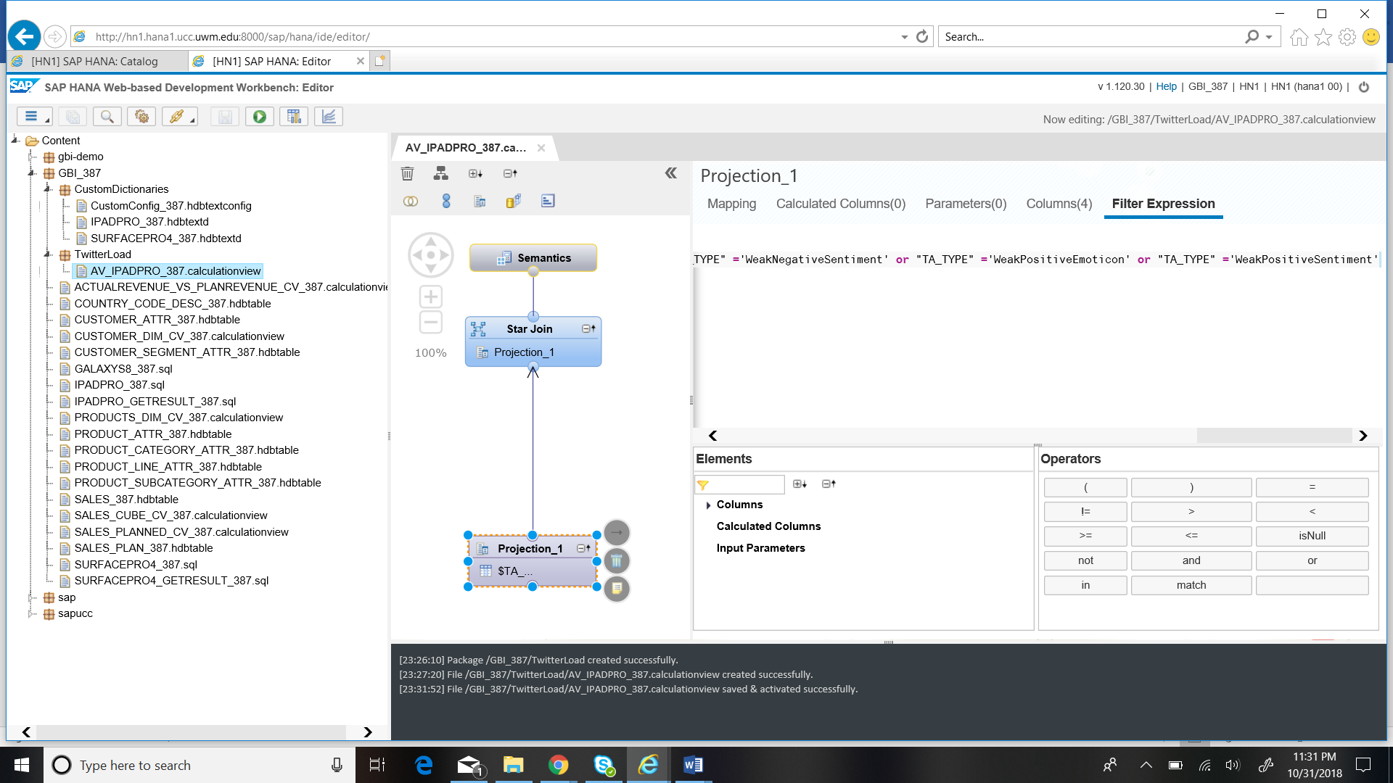

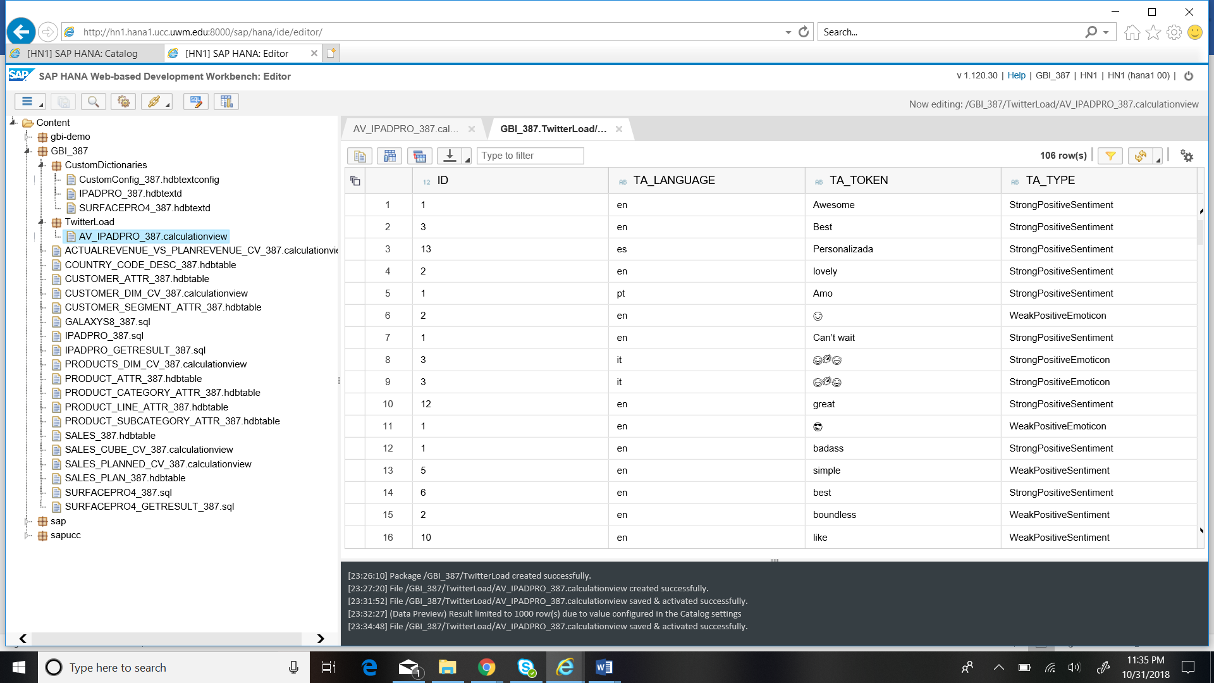

**SurFacePro4**

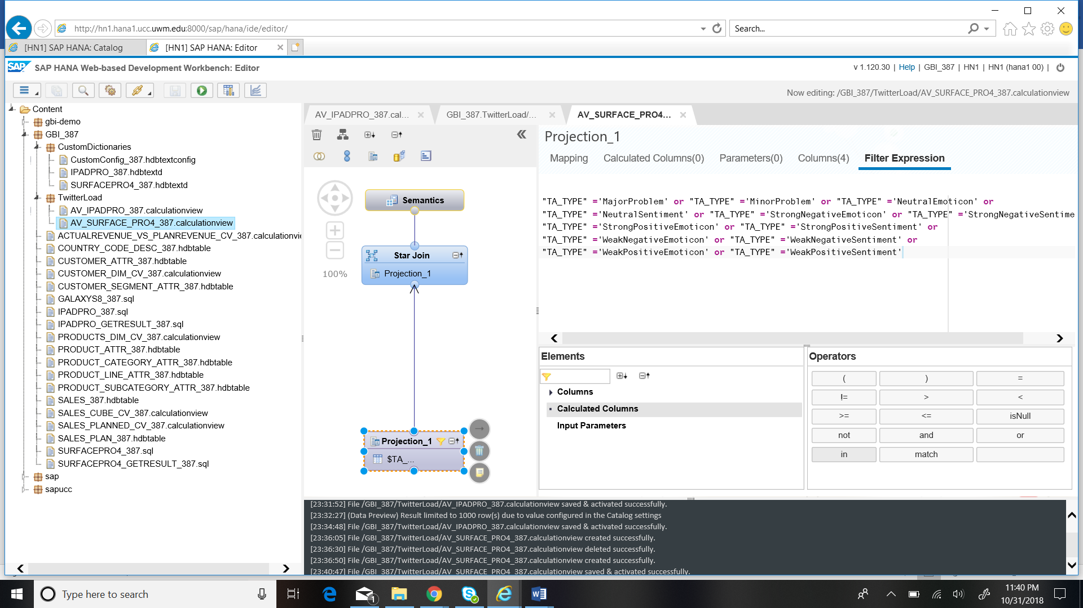

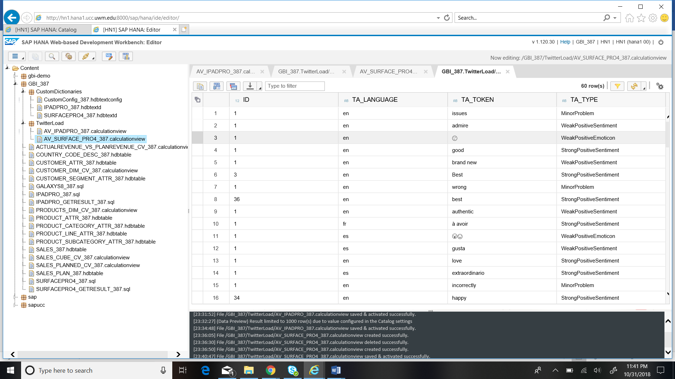

**2) SurfacePro4**

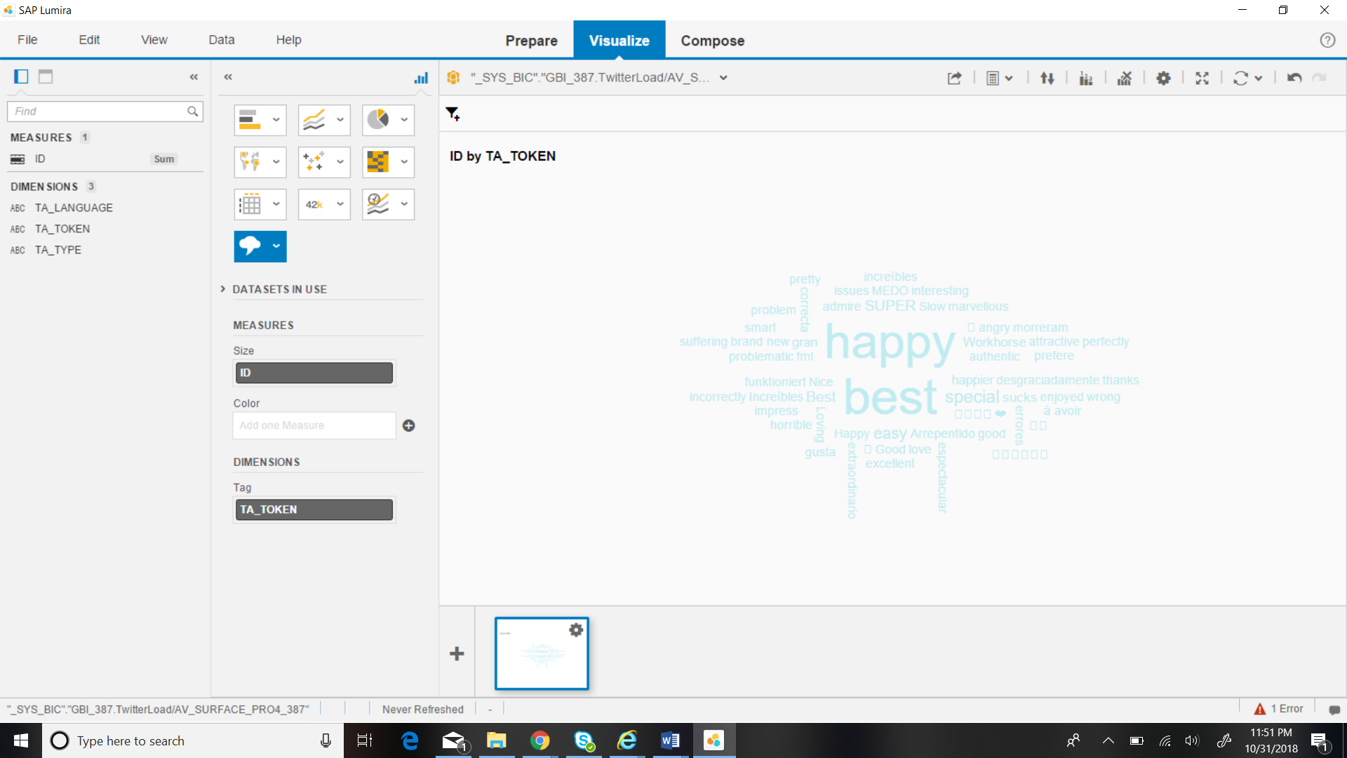

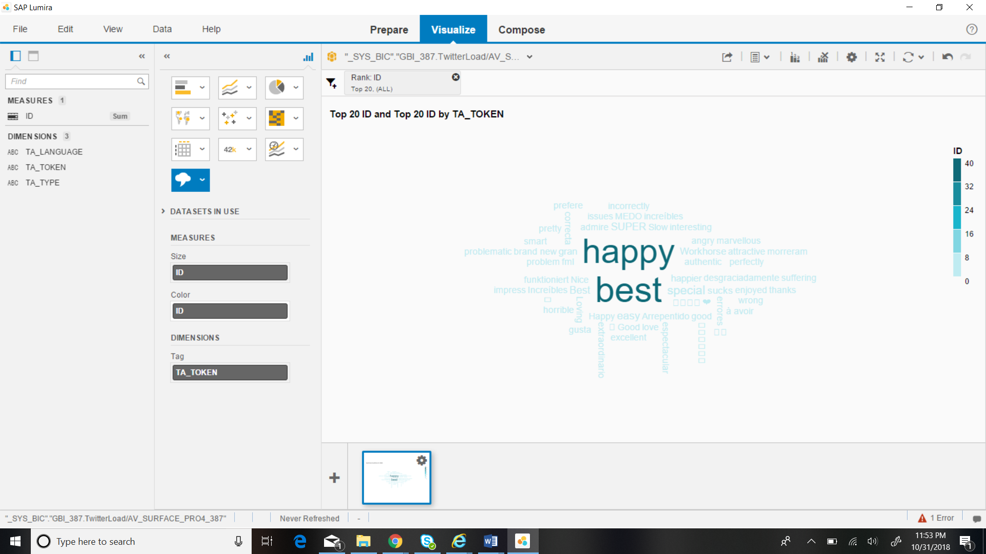

**iPadPro**

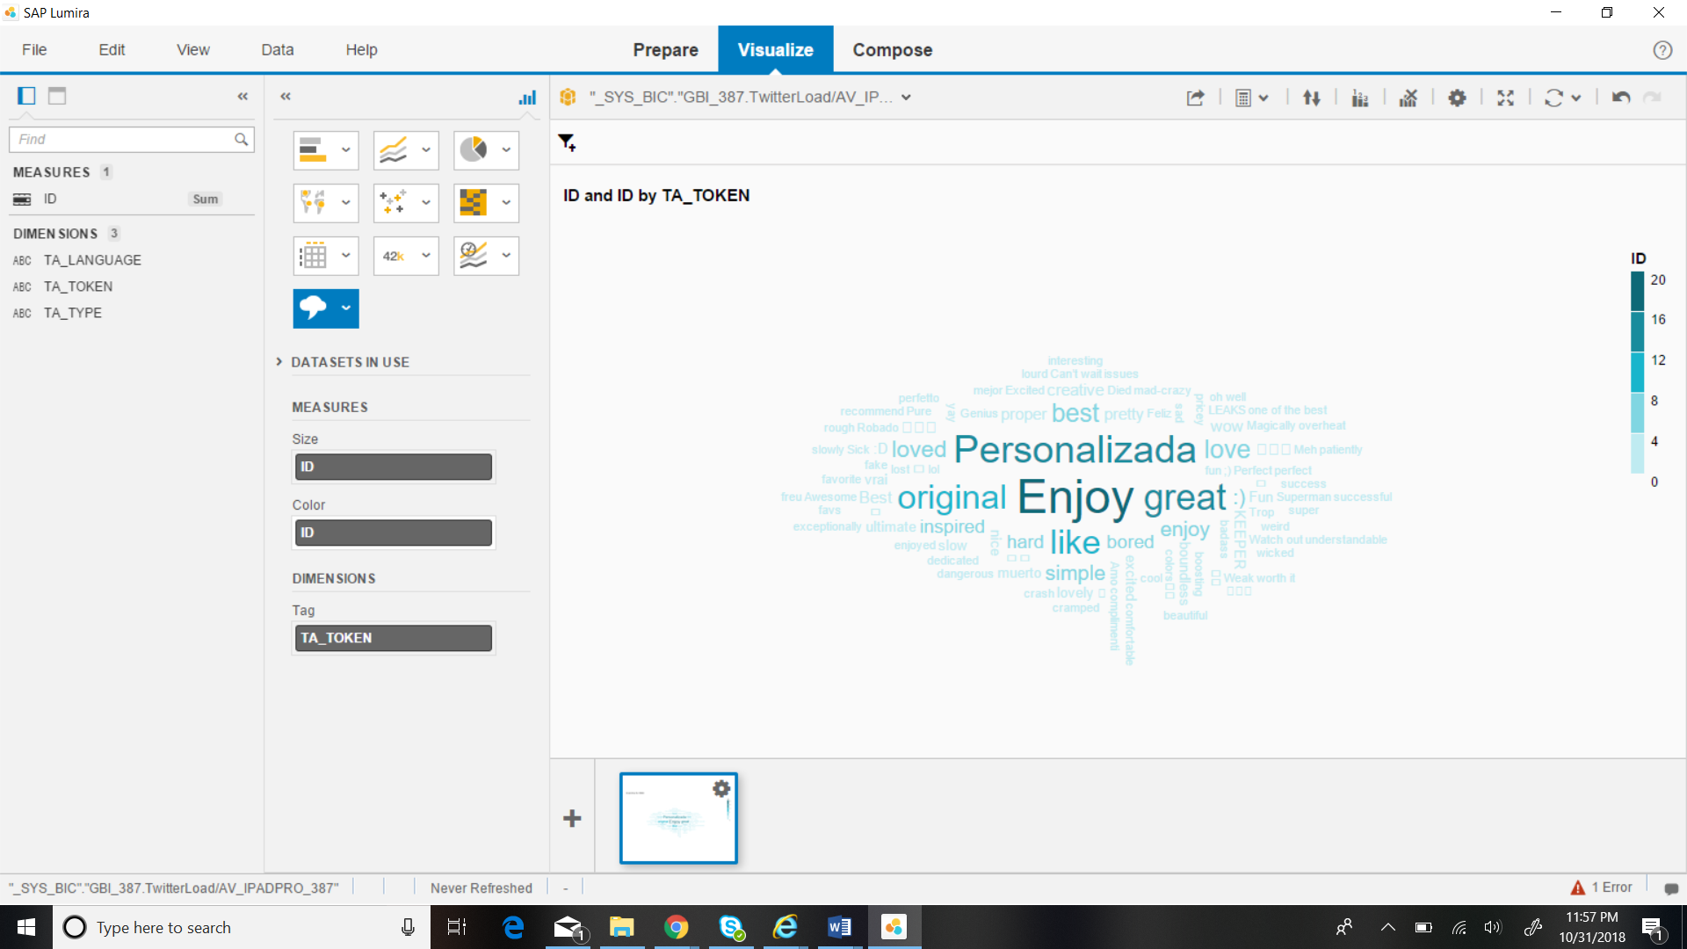

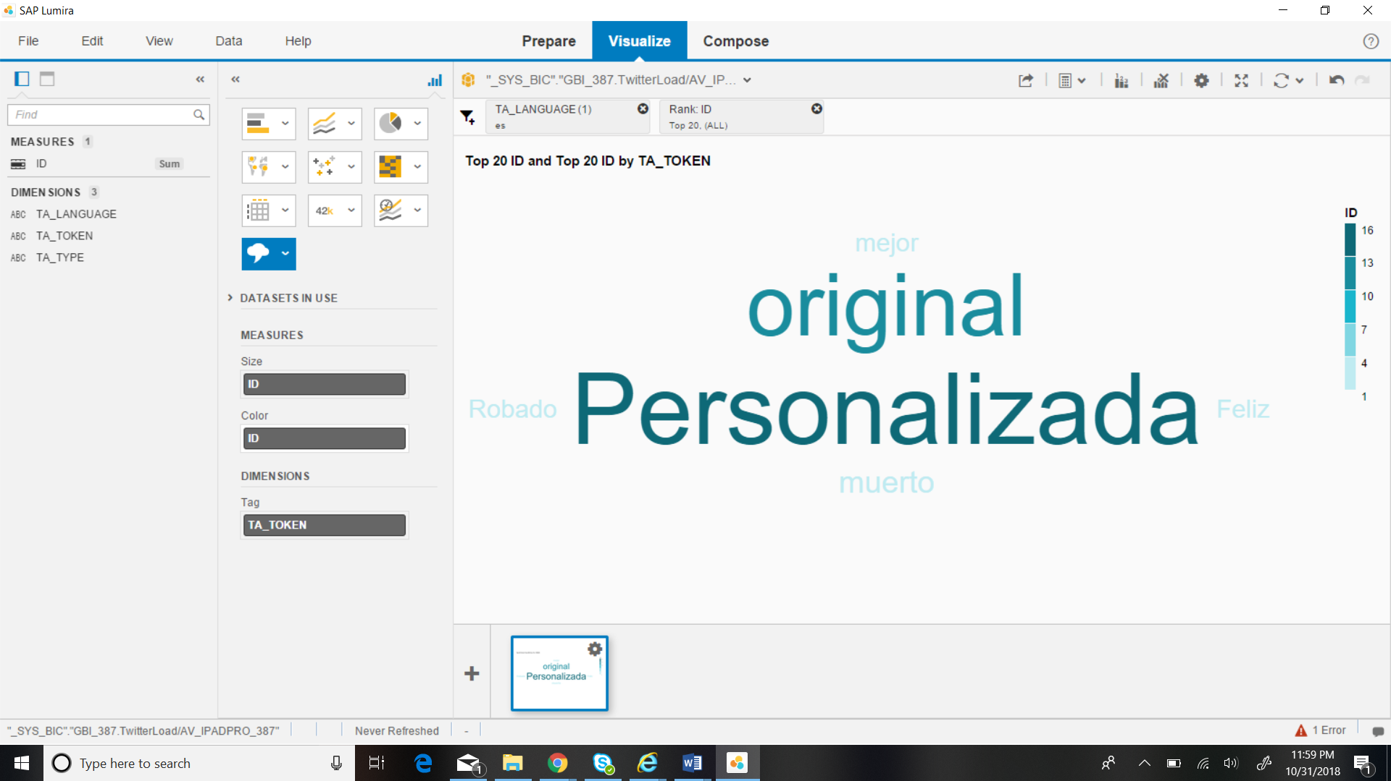

Sentiments after filtering by language and sorting by rank -

Personalizada = Custom

Original = Original

Muerto = dead

Robado = Stolen

Mejor = Best

Feliz = Happy

The Sentiment analysis of iPadPro depict the behavior of the custom towards the product. Many customer have the” Personalizada” meaning ‘customized’ and original feeling towards the product. But among them few of the customers iPadPro is not working i.e “Muerto” meaning ‘dead’ and few of them iPadPro is “Robado” meaning ‘Stolen’. Some percentage of customer are “Feliz” meaning ‘happy’ and according to few it is the “major” meaning ‘best’ product to use.

**3)**

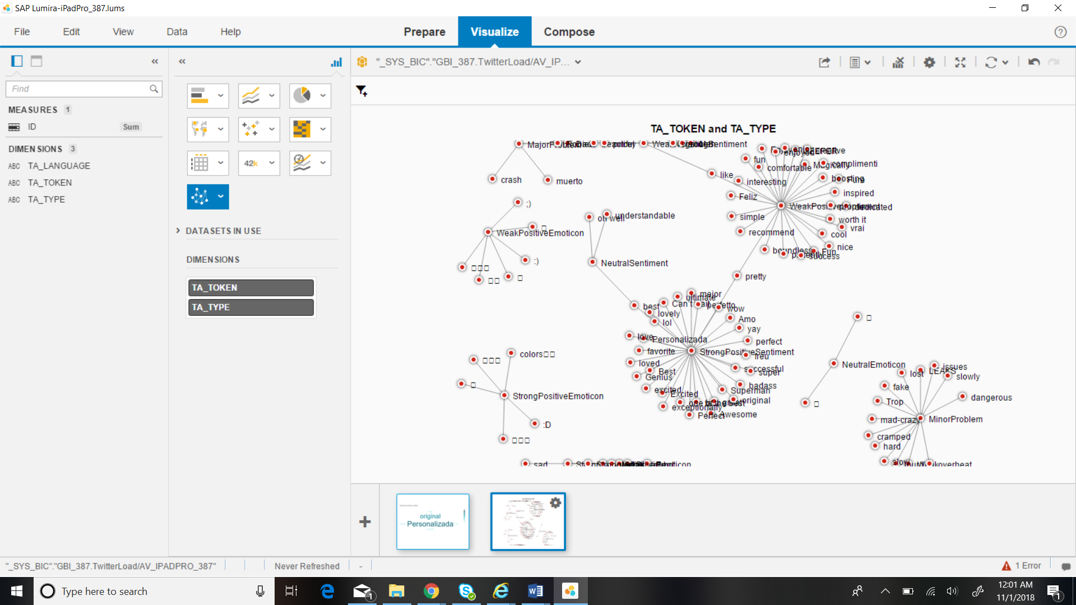

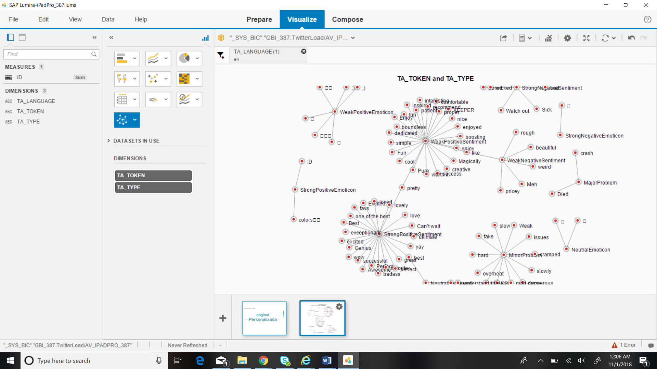

**WeakPositiveSentiment**

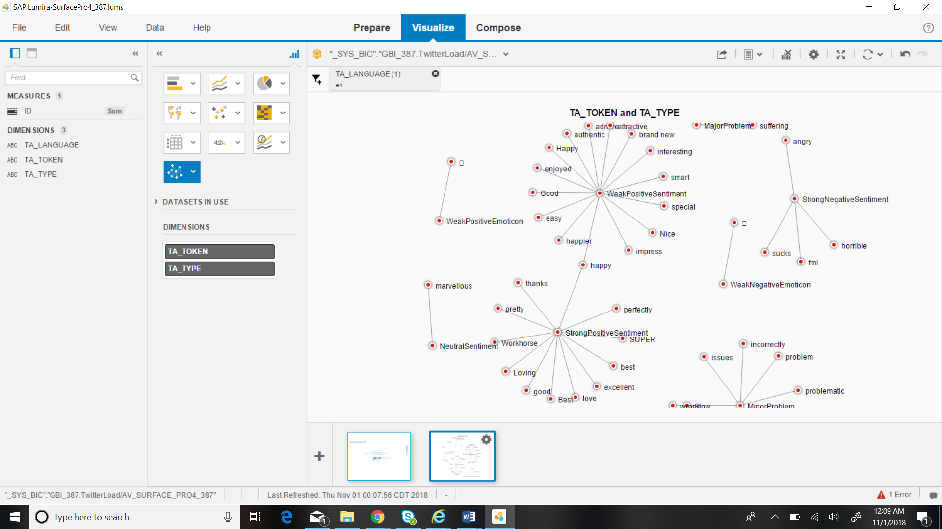

**4)**

